Executive Summary

The minimum legal drinking age (MLDA) in the United States has long been disputed. Given the task of proposing a lower MLDA, we have suggested the age of 19 based on our research. After prohibition, many states adopted the age of 21, but later lowered it. Many tragedies were blamed on the lower drinking age. Currently in Wisconsin, one can but can pour, sell, and serve alcohol at the age of 18, but not drink it until the age of 21. Wisconsin and many other states are moving to a 0.08 BAC for driving due to a federal mandate, fearing the loss of highway funds. Advocates argue an “international standard” as the basis for passing the federal mandate; however they disregard the same standard for the MLDA. In Wisconsin there are DRAM shop laws in place. Servers who have served someone caught driving under the influence can be fined $500-1000, jailed for 30-60 days, or lose their license.
Currently, people the likes of Attorney General Jim Doyle, Democratic National Chairman Howard Dean, and Representative Norm McAllister are pushing for a lower MLDA. College students and other young people have also joined the movement. They cite reasons such as the “international standard,” mentioned earlier as well bringing drinking into a socially acceptable venue and out of unsupervised situations. They also express discontent with the federal government’s perceived black mailing.
There are many positive effects of drinking alcohol, and lowering the MLDA may extend these to young adults. One study showed the risk of death was highest when abstaining from alcohol and drinking excessively. The risk was lower when drinking in moderation. The same study showed any amount of alcohol reduces the likelihood of cardiovascular diseases. Some scientists suggest drinking a moderate amount wine daily to prevent a second heart attack. Many agree that moderate amounts of wine reduce the risk of coronary heart disease. Alcohol has been shown to reduce the effects of aging and Alzheimer’s disease as well as positively affect women’s bone mass density.
There is no clear-cut explanation as to how alcohol affects the brain. We recognize the studies that show alcohol consumption could hamper the development of the cortex in young people. When comparing IQs of countries with lower drinking ages, many have higher IQs while alcohol consumption is greater and the minimum age lower than in the US. Thus alcohol consumption does not directly lower IQs. In fact, one study done in Japan and reported by the BBC suggested IQs of alcohol consumers were higher. It is important to recognize that the brain continually changes, with or without alcohol consumption.

Lowering the Minimum Legal Drinking Age

The Underagers

Luis Aguilar
Jesse Aurit
Katie Cummings
Emily Gnadt
Dan Kelly
Mike Petersen
Bob Telford
Linda VanVonderen
Mike Will

Professor Meyer

Contents Page

Executive Summary i
Title Page ii
Table of Contents 4
Introduction 5

The Problem
Our Proposal
Supporting Arguments
Comparison to Other Countries

History of Drinking Age 7
Current WI Laws 8
Current Movements 10
Positive Effects of Alcohol 12
Traffic and Alcohol Statistics 15
Increase Education 25
Facts vs. Myths 27

Myth #1: Traffic Fatalities Will Increase

Myth # 2: Cultural Perspective
Myth # 3: High School Dropouts Will Increase
Myth #4: Maturity Levels Too Low

Myth #5: Teen Pregnancy Will Rise

Myth #6: Alcohol Kills Brain Cells

Myth #7: The Age 21 Law Has Been Successful

Recommendation/Conclusion 31
References 33

Appendices

A. Statistical Graphs & Charts 35
B. PowerPoint Presentation Slides & Notes 45
C. Rejected Proposal 51

Introduction

Our task was to develop the proposition that the current 21-year-old drinking age should be lowered. To do this we will present the problem, our proposal, arguments that support our position, and some comparisons to other countries. Finally we will dispel some myths and make some recommendations. We began with brainstorming all the things one can do upon their 18th birthday in the United States. This lengthy lists includes risking one’s life for this country in the service, voting for the people that will lead and make important decisions that govern our country, terminating the life of another (in the act of an abortion), serving on a jury and thereby determining the future for another person, making a lifetime commitment in the way of marrying a partner, purchasing a home, being convicted as an adult in court, paying taxes, purchasing guns that could take the life of oneself or another, gaining approval for credit cards, purchasing cigarettes, and last but not least, being sentenced to death in those States that have the death penalty.
The Problem
The problem on the table is what the legal drinking age should be. The first assumption we made is that alcohol needs to be kept out of high school. High school students don’t need to be arriving on Monday morning to take an important test with a hang over. Also, since most high school students hang around with other high school students, it would make it that much easier to hand the alcohol off to the younger people. Next, the majority of people drink underage, that is, before they are 21 years of age. While we aren’t condoning this behavior of breaking the law, we are aware that the current law is not effective. Lastly, maturity levels appropriate for consuming alcohol are reached by the age of 19. From the list presented above, it seems obvious that this country considers people mature adults at the age of 18. From the harmless responsibilities of paying taxes to the more volatile opportunities like owning weapons and purchasing cigarettes, it seems absurd that alcohol would be kept from adults under 21.
Our Proposal
Therefore, our proposal is to reduce the minimum legal drinking age to 19 at a federal level.

Supporting Arguments
Lowering the drinking age is likely to move drinking out of basements, as the saying goes, and into bars. Why is this important? Young people who are drinking may not be aware of some of the consequences or possible dangers. If they head to the basement or secluded areas to avoid getting caught and someone passes out or experiences alcohol poisoning, they are not likely to receive the medical treatment they need. Either people will be too drunk to understand the person is in danger, or they will be afraid of getting in trouble once they head to the hospital. This may also be the perfect environment for violence or sexual assaults, as people aren’t thinking clearly. Not only that, but bars offer the advantage of being able to refuse to serve any more alcohol to someone that’s obviously had too much. Follow this up with free or discounted transportation and the advantages cannot be ignored. There is an important social aspect to drinking that needs to be appreciated, as well as the opportunity for young adults to observe responsible drinking. This would allow the younger adults to participate in all the other activities and fun to be had at bars, including pool and sports.
There is also pressure from the media to lower the drinking age. This can be seen in articles like the one in a recent issue of Teen Vogue as well as on television. In those stories the author(s) and producer(s) attempt to cover both sides of the issue while staying neutral, however, ultimately they do have a bias to cater to their viewers or readers.
Comparison to Other Countries
Most people are aware that other countries have lower or no drinking ages. Poland, for example, has no minimum drinking age. Italy and Spain are at 16 while Australia, the United Kingdom, and Hungary are at 18. South Korea is at 19 and Japan is 20 years of age. Many of these countries are similar to ours as far as education levels and economic interests are concerned.

History of Drinking Age

After Prohibition, nearly all states restricting youth access to alcohol designated 21 as the minimum legal drinking age (MLDA). Between 1970 and 1975, however, 29 states lowered the MLDA to 18, 19, or 20. These changes occurred when the minimum age for other activities, such as voting, also were being lowered (Wechsler & Sands, 1980). Scientists began studying the effects of the lowered MLDA, focusing particularly on the incidence of motor vehicle crashes, the leading cause of death among teenagers. Several studies in the 1970s found that motor vehicle crashes increased significantly among teens when the MLDA was lowered. That evidence, and the continued decrease in drinking and driving, has been used as the main argument for keeping the legal drinking age set at 21. We will point out in our Facts vs. Myths section that there are other factors involved in the reduction of drunk driving, and that it is not necessarily related to the MLDA.

Current WI Laws

The legal age to consume alcohol is 21, but the legal age to pour, sell and serve alcohol is 18. Apparently an 18 year old is responsible enough to serve alcohol, but not to consume it.
The limit for driving is a BAC of 0.08. In October of 2000, the federal government passed a mandate for states to reduce the BAC level threshold for DUI in their state to .08. The states have four years to reduce the BAC level to .08 or they will begin to lose federal highway funding. Many states have introduced legislation to reduce the BAC level to .08 but, as one can imagine, this is a hot debate and some states have not passed it into law. Drunk driving penalties are the same in many instances whether the drinker has consumed one ‘swallow’ too many or a ‘bottle’ too many. One point that is rarely heard is that advocates often argue that the "international standard" for BAC is .08 or lower and the US should go to .08 as well. Following that logic, the "international standard" for minimum purchase age is 18. Are those same advocates willing to lower the minimum purchase age as well? Currently only 16 states have adopted .08 BAC.
There is a zero tolerance rule adopted by all 50 states for drivers under the minimum drinking age.
In Wisconsin, there is no limit on the maximum amount of alcohol in each drink and a server can serve any number of drinks at one time to a person of legal age.
Wisconsin also has what are called DRAM shop laws. These are laws that hold alcohol servers responsible for harm that intoxicated or underage patrons cause to other people (or, in some cases, to themselves). These laws are established at the state level through common law, legislation, or both. Dram shop liability laws are especially important in preventing alcohol problems because regulatory agencies - mainly state Alcohol Beverage Control departments - are so ineffective. In particular, these laws can provide an incentive for owners of alcohol establishments to train their employees in responsible beverage service.

Social host liability laws are similar, where the host of a gathering or party can be held liable for the alcohol served at the party. A good example to think of are Office Christmas Parties, which can be a drunk-fest depending on the organization, but it is important to remember that if someone attending the party drives, and hurts someone else, the company hosting the party is part liable in a court of law.

It is sometimes legal for minors to drink in the presence of their parents or a legal guardian. The main points covered in these laws are:
- A minor (someone under age 21) can legally enter a bar or liquor store with their parent or guardian (who is at least 21) present and consenting to the act. If a person is married and the spouse is 21, then upon proof of marriage the underage spouse may enter the establishment and legally consume alcohol.
- The law also talks about the presence of minors in a bar or restaurant, if more of the business’ revenue comes from food, then the minor may enter the premise, but may not be in the bar room.
- Note that there are exceptions to these restrictions, and that local governments have the power to change these laws, and enforcement policies.
Here are some penalties for servers caught catering to underage patrons:
- First Offense -- up to $500 fine;
- Second Offense -- up to $500 fine and/or 30 days in jail if a previous violation has occurred within 30 months of the violation;
- Third Offense -- up to $1,000 fine and/or 90 days in jail if the previous two violations occurred within 30 months of the violation.
- The penalty for serving someone who is visibly intoxicated is a $100-500 fine and 60 days in jail. Licenses may also be revoked.

Current Movements
Wisconsin Attorney General Jim Doyle favors lowering the legal drinking age to 19 if the age was adopted nationally. "I wish the federal government, when they're thinking about 0.08, would think about a uniform drinking age of 19," Doyle said in an interview with the Telegraph Herald (Dubuque, IA). "I think this idea that somehow we're going to keep kids between 19 and 21 from drinking is a myth. We should recognize it's a myth. We ought to put it up front, and be morally responsible about it." Doyle knows from experience with his two sons. "I would rather have them drinking in a setting where somebody's checked an ID at an establishment," Doyle said, instead of an unsupervised situation where "200 kids will crowd into a basement of a house, turn off all the lights and drink themselves sick."

By the time he was 19 years old, Rep. Norm McAllister, had graduated from college, wed, and started basic training for the Vietnam War in Leonard Wood, Mo.
“But in my home state,” McAllister, a Vermont native, said in February 2005, “I was not old enough to consume an alcoholic beverage. I couldn’t make sense of it then, and I still can’t.”
He has led a push within the Vermont house to lower the drinking age. One of his reasons is that former governor and new Democratic National Chairman, Howard Dean has argued for the lowering of the drinking age. What prevents them from taking immediate action is the possible loss of federal highway funding. In fact, they both state that the roads and bridges are in disrepair and they are unsure of how the federal money is being spent. The state representatives are being held hostage, and one even states that “Although I am not totally against it (lowering the drinking age), I would not support or vote for this bill, because I don’t think we should take a chance of losing $9 million in federal transportation money.” This is not the right message to send the people. It’s a form of black mail by the federal government and is unfair.
In Kansas, the students are leading the charge to change the drinking age. They believe that it is unfair to the youth that have the right to do everything else but drink.

The Health Effects of Alcohol
There are various health benefits to consuming alcohol. Some people may have a problem believing that alcohol is actually good for your health. The graph below, from a government report in the New England Journal of Medicine, shows that the risk of deaths per 100,000 is higher if you abstain from alcohol. It is quite a bit lower with a small number of drinks per day, and then it increases with excessive consumption. The key, of course, is to drink it in moderation. It is important to note, that in this study, it was concluded that even a slightly higher consumption rate (as much as six drinks per day) still had a lower correlation when compared to subjects that abstained from alcohol. The study shows that any amount of alcohol decreases the likelihood of contracting cardiovascular disease.
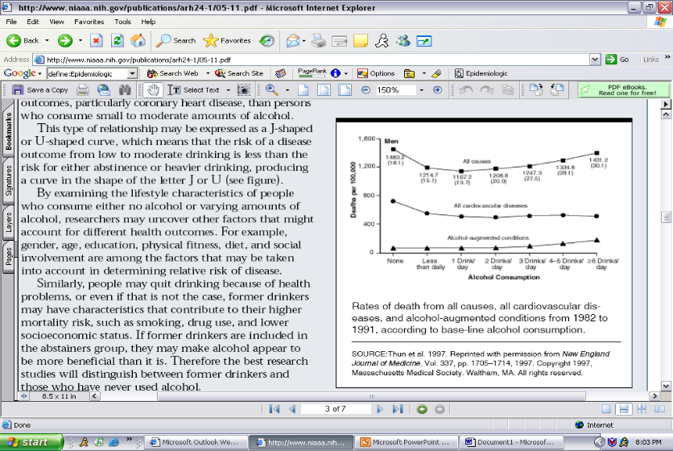

The previous research has shown that drinking wine in sensible amounts may reduce the risk of coronary heart disease. There have been vast studies that explain the cardiovascular benefits for consuming alcohol, which makes it ultimately good for the heart. Some scientists even say that one way for coronary patients to minimize the risk of a second heart attack is to drink (a moderate amount of) wine every day.
Alcohol has also been shown to reduce the effects of aging, and the risks associated with Alzheimer’s disease, as well as having positive effects on the bone mass density (BMD) of women.
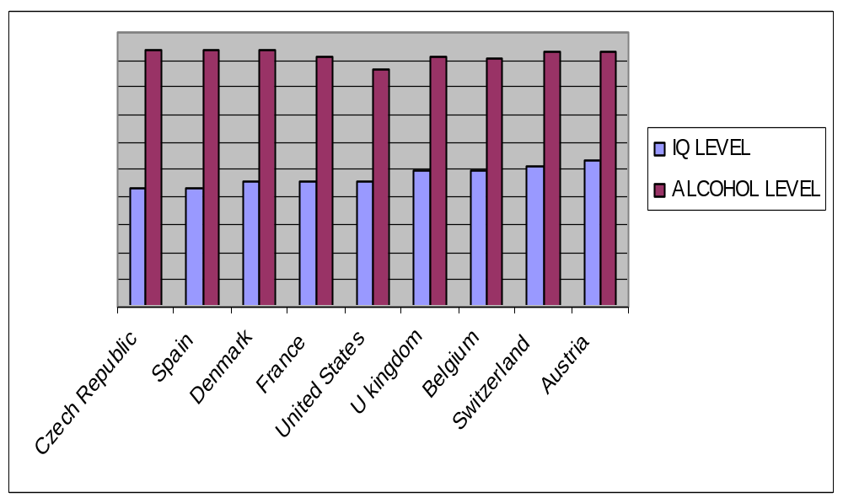
Some people argue that brain development is hampered by alcohol consumption. We are not dismissing the fact that there could be a problem with the drinking of alcohol and the development of the cortex, however we compared the IQ of other countries and the amount they drink per capita per year. The chart below shows that although the countries all have lower minimum drinking ages than the United States, and they all drink more, they have a relatively similar IQ level. This is suggests that the alcohol consumption does not damage the brain as much as thought, or at least, that the damages do not affect IQ.

Of course there are some potentially problematic heath effects associated with alcohol consumption. For example, there is research that has shown that there are increased cases of Liver Cancer than in the United States. This is tough to dispute; however, we feel that the benefits that we have suggested (with adequate research) are more beneficial, and thus the benefits of a lower drinking age will outweigh the costs. It is important to note that in our proposal and final recommendations we call for better alcohol education. This education would be necessary to ensure that alcohol is consumed moderately, thus creating the greatest number of health benefits.
Moreover, one study conducted by a Japanese researcher and published on the BBC news wire a few years ago states that alcohol improves IQ. The researches, at the National Institute for Longevity Sciences near Tokyo, tested the IQ’s of 2000 people between 40 and 79 years old. Men who drank around 540 milliliters of sake or wine a day had an IQ of 3.3 points higher than men who did not drink at all. Women were 2.5 points higher. (Alcohol ‘improves IQ’, 2000)
A person’s mind and body continue to grow and change throughout life. A 21 year old is different from someone who is 18. Likewise, 41 year old is different from a 38 year old. Activists who argue for the raising of the drinking age ignore the fact that maturity is a gradual, but uneven process that continues throughout life, and is not complete on one’s twenty-first birthday. Moreover, they ignore the proven medical fact that the moderate consumption of alcohol is associated with better health and greater longevity than either abstaining completely or abusing alcohol. The simplest way to prove this argument is to look in the medicine cabinet or go to the local drug store. Over-the-counter medication defines an adult dose to be ‘for ages 12 and up’. Not 21, but 12. If the FDA can determine that a 12 year old is developed enough to have an equal dose of Tylenol, Sudafed, Dramamine, or Zantac 75, as an adult, then a 19 year old should be ‘developed’ enough to have a glass of wine with dinner.

Traffic and Alcohol Statistics

First, some definitions:

BAC or blood alcohol concentration is the amount of alcohol in the blood measured as .01 grams per deciliter

Intoxicated simply means that one’s BAC was over .08 limit.

NHTSA defines an alcohol-related fatal crash as, “(one) that was reported by a law enforcement agency and involved a vehicle operator or a non-occupant (e.g., pedestrian) with a blood alcohol concentration (BAC) of (0.01 g/dl) or greater."

Non-occupants are the people involved in fatal crashes who were not occupants of any vehicle. They could be pedestrians or people riding their bikes who were hit.

NHTSA, whenever referenced refers to a report released this year about Alcohol Traffic Statistics published by the NHTSA (National Highway Traffic Safety Administration) and the NCSA (National Center for Statistics & Analysis).

These are some of the statistics we weeded through on the Mothers Against Drunk Driving, or MADD’s website. There were hundreds of statistics with links to many more pages. But, remember that MADD has a political agenda to influence politicians to pass laws regarding alcohol. Although MADD cites all sources, it would probably be a safe assumption to say that they were cherry-picking with the statistics they decided to place on their website. Never the less,

In single-vehicle fatal crashes occurring on weekend nights in 1999, 66% of the fatally injured drivers 25 years of age or older were intoxicated, as compared with 56% of drivers under the age of 25. . (NHTSA, NCSA 2002). One could conclude that older drivers (over 25) are more likely to be involved in fatal crashes on the weekend. However, this statistic is unclear in the fact that it doesn’t define what a driver under 25 is. Is it 21-25 year olds, or all drivers under 25?
Another statistic is that d
uring a typical weekend, an average of one teenager (15-20) dies each hour in a car crash. More than forty- five percent of those crashes involve alcohol. (NHTSA, NCSA 2002) This is a powerful statistic, but it doesn’t show that some of the teenagers killed in these crashes might have not been drinking, and it may have been just coincidental that they died as a result of another driver who was drunk. We cannot conclude from this statistic that all of the teenagers were drinking themselves.

Younger people (age 16-20) are most likely, of any age group, to use various strategies, when hosting a social occasion where alcohol is served, to try to prevent their guests from drinking and driving. (NHTSA, 2002). This is an encouraging statistic, and shows the importance of thinking when you drink, even if the drinker is underage.
Here is something to think about, Canada’s Drinking age is 18-19, depending on province, and the 1998 Alcohol-related Canadian deaths were 38.2% of all accidents. (MADD Canada). Contrastingly, in the US in 2000 the rate was near 40%, but the minimum drinking age is 21. Can a valid comparison be drawn here?
We will now move on and talk about a report that was released about Alcohol Traffic Statistics published by the NHTSA (National Highway Traffic Safety Administration) and the NCSA (National Center for Statistics & Analysis). Their findings are interesting, but are susceptible to scrutiny, since they are not going to be likely to publish a document that shows information contradicting that of the law or of a support group similar to MADD in fear of the political pressure MADD can exert.
NHTSA estimates that alcohol was involved in 40 percent of fatal crashes and in 8 percent of all crashes in 2000.
This is simply an estimate based on previous trends, remember the future is hard to predict. The NHTSA likes to show that alcohol-related fatal accidents make up far more than only 8% of all crashes by saying that it was 40% of fatal crashes. With a little simple math, only 3.2% of all accidents were fatal alcohol accidents, upon which the NHTSA bases most of its research after.

The 16,653 fatalities in alcohol-related crashes during 2000 represent an average of one alcohol-related fatality every 32 minutes. (NHTSA) This is difficult to defend. We open another can of worms when we talk about collection issues.

For example, were the BAC results from breathalyzers or from blood tests? If there was not a consistent test, then the results are inconclusive. It’s easy to imagine that sometimes no test was done, but the accident is recorded as alcohol related because the victim smelled of alcohol. What if the victim worked in a brewery or as bartender and was sober, but because no test was done, it shows in this report.
What about the fact that some of the fatalities above were those who could have been 100% sober, but killed by another drunk driver.
How did the person die? Was it of natural causes at the hospital hours after the accident? Or was it a medical malpractice or a busy hospital? Perhaps their death was coincidental with the crash. We don’t know this as fact but can certainly see how some deaths like this could be included. (Refer to the definitions above.)

Another interesting statistic which falls under the last argument is that an estimated 310,000 persons were injured in crashes where police reported that alcohol was present — an average of one person injured approximately every 2 minutes. (NHTSA) The accuracy and the significance of these statistics remain to be seen.
The table below shows the types of fatalities in fatal crashes involving at least one intoxicated driver or non-occupant. This table is deceiving because nearly 31% of the people who were killed were either passengers or non-intoxicated. (6+21+4). Also, the intoxicated non-occupants were 12% of all fatal alcohol accident victims, the driver of the cars involved may have been sober, but because the non-occupant was intoxicated, they are automatically involved in the fatal alcohol crash, and get added into the numbers.
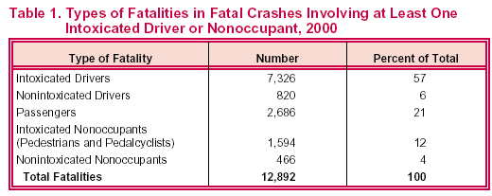

The figure below does a nice job of confusing some readers into seeing what the NHTSA wants them to see. First off, this graph manipulates the brackets of ages. Why are ages 16-20, and 21-24 relatively small groups, while groups of 25-44 and 45-64 have nearly 20 years of separation between them. We might see a different looking graph if the age groups were distributed equally. Why is a 16 year old grouped with a 20 year old, a 20-year-old’s driving experiences will without a doubt have been far greater, and therefore a 20 year old should be a better driver. It is possible the data representing the 16-20 ages is skewed because of overrepresentation of the 16 year olds’ inexperience with driving (and alcohol). It begs the question, “What determines someone’s age?” What if they are on the border between ages, for example if one turns 22 on Thursday, does that mean if they were to die in an alcohol related crash on Tuesday they would be listed as a 21 year old, even though they have been alive 21 years and 51 weeks and 5 days? Only 2 days remaining before officially turning 22. A better argument would be if the person were on the border between age groupings. Borderline cases will cause misrepresentation no matter what is done.
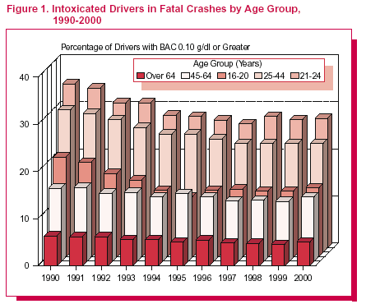
Also notice the order of the bars in the graph. They are not in numerical order, but in height order.

With those points aside, one can clearly see that over the past 10 years the fatalities across almost every age group has decreased. What we can’t see in this graph is the reasons for the decrease. Perhaps it can be attributed to:
    - Safer cars with better airbags and safety equipment
    - Smarter people, not drinking as much before driving, (remember this graph only shows fatalities when the driver had a BAC greater than .1)
    - Tougher laws, and the new .08 BAC standard
    - Political groups like MADD, SADD, RADD, and the like.
    - Information campaigns on TV, and radio, similar to the “Think when you drink” campaign.

    - No one thing can be pointed to as the cure all to end drinking and driving

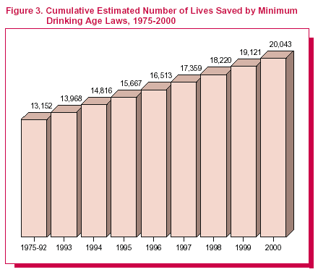
The next figure seems to hurt our case, but there are some things wrong with the way the information is presented. First of all, it groups all years from 1975 to 1992 in one bar, which it should since every year after 1992 is compounded on the total. It almost looks as if each year we are saving nearly 20,000 lives from drinking age laws the way they are, when in fact only an estimated 922 lives were saved in 2000.

This graph also starts all the way back in 1975, nearly a decade before the national standard was 21. How many of the 13,152 people saved between 1975 and 1992 were under the 21 age is also unclear. Is this increase due to other things and not the drinking laws?
The next simple table compares the fatal crashes from 1990 and 2000. We can see that the percentage with a BAC greater than .1 was 40% of the fatal accidents in 1990 and 31% in 3000. The NHTSA says that there has been a 23% decrease in the fatalities from 1990 to 2000. Perhaps Americans are being more responsible with their drinking and people are drinking less, but we can not prove that.
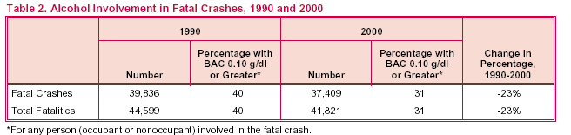

One can see from the next chart that fatalities have been relatively steady for the past few years. It should be noted that in the report this was taken from there was a note, “Alcohol-related crashes refer to drivers with Blood Alcohol Concentrations of .01 grams per deciliter or higher. NHTSA estimates alcohol involvement when alcohol test results are unknown.” I guess that if people estimated alcohol involvement when they are unavailable, it could tend to be biased, so it suggests that the actual number is quite lower than that shown below.
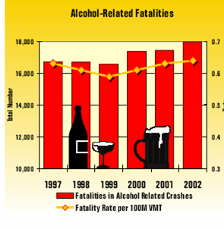

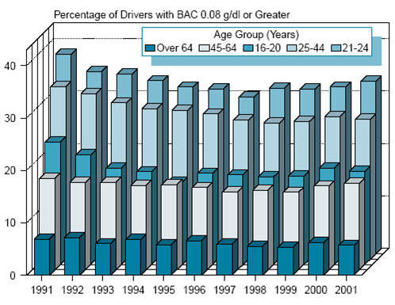
In 2001 there were 17,448 fatalities in alcohol-related crashes. This is a slight increase compared to 2000 (17,380 fatalities), and it represents an average of one alcohol-related fatality every 30 minutes. The 17,448 alcohol-related fatalities in 2001 (41 percent of total traffic fatalities for the year) represent a 13 percent reduction from the 20,159 alcohol-related fatalities reported in 1991 (49 percent of the total).

In 2001, 35 percent of all traffic fatalities occurred in crashes in which at least one driver or non-occupant had a BAC of 0.08 g/dl or greater (as shown in the graph above.)
As the graph below shows, alcohol involvement — either for the driver or the pedestrian — was reported in 47 percent of the traffic crashes that resulted in pedestrian fatalities. Of the pedestrians involved, 33 percent were intoxicated. The intoxication rate for the drivers involved was only 15 percent. In 6 percent of the crashes, both the driver and the pedestrian were intoxicated.

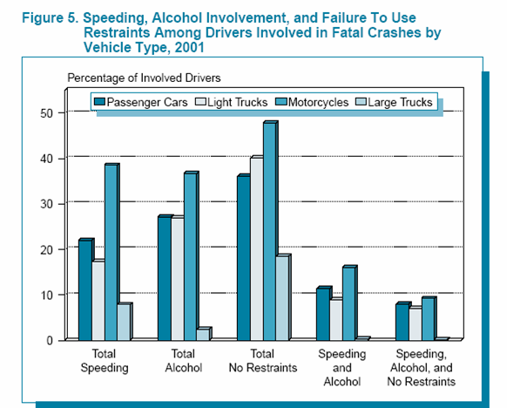

Finally, the last graph below shows that the fatal crashes have decreased over time, but one cannot say for certain that the reason is because of the drinking age laws.
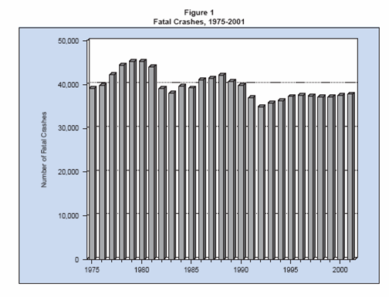

We have tried to present how many of the statistics generated by the NHTSA and other agencies can be biased by political agendas. Many of the conclusions that are drawn by those agencies about traffic fatalities and their relationship to alcohol are used to support the myth that if the drinking age is increased, traffic fatalities will increase.

Increase Education
An increase in alcohol education related to the responsible consumption of alcohol is important to our argument that the drinking age should be lowered. A reform in the current drinking education is necessary to teach young people that drinking is a privilege, not a responsibly. It should be taught that responsible drinkers:
- Don’t drink too much
- Don’t drink to play games/contests
- Don’t drink to forget problems
- Do not drink on an empty stomach
- Do drink in moderation

Education about alcohol should not only take place in the classroom, but from the parents. Colonial Americans who drank with their parents and as a result alcohol problems were rare. The various positive effects of parents educating children are:

Alcohol viewed as a actual substance

Abstinence and moderation acceptable

Supporting Environment to learn responsibility

Unties relating alcohol with maturity and adulthood

There are some cultures that have education in place (e.g., Italian, Chinese, Greek, and Jew) that teach alcohol is not a poison or magical substance. This would ultimately remove the stigma that by drinking alcohol you will ultimately forget the past. There is no pressure to drink as a right of passage; one can drink on their own or at certain times in their life. It has become a tradition for many in the United States to hit the bars and drink on their 21st birthday, which is not present in other cultures. Also children learn form parents on how to drink, instead of from their friends and popular movies, which often depict reckless drinking.
Increased education would help reduce the social problems of alcohol. Education is warranted because MADD posted that 41% of the driving age public said they do not know whether their state has a different BAC limit for drivers under the age of 21. Those who thought their state had a lower BAC limit for young drivers were asked to say what they thought it was; only 12% of those people got the correct limit. (MADD). This is only one of the common problems with the current education of lack of education. Past education has proven to be as effective as laws on preventing driving under the influence of alcohol, and has helped to reduce binge drinking on college campuses. Future education needs to involve student input. As previously stated, alcohol should be treated as a responsibility not a privilege.

Facts vs. Myths

Myth #1: Traffic Fatalities Will Increase
The graph below demonstrates the importance of increased restraint use and safety devices in automobile drivers. Traffic Fatalities have diminished steadily over the past 35 years. Even when the Minimum drinking age was changed to 21, there was not a significant drop in the overall fatalities. This graph includes all motor vehicle fatalities, not just the alcohol-related.
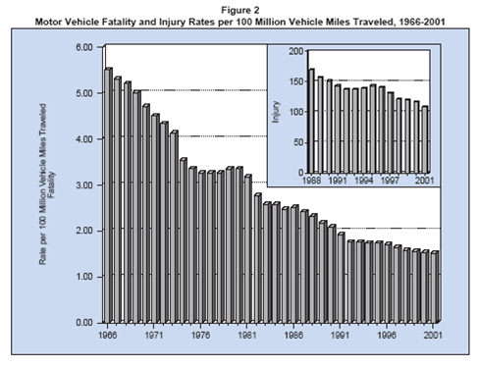

The next graph from the same report shows that the percent of alcohol in fatal crashes was around 40% of the total for the age group, and then it was less after that. However, one should pay attention to the two notes at the bottom of the chart.
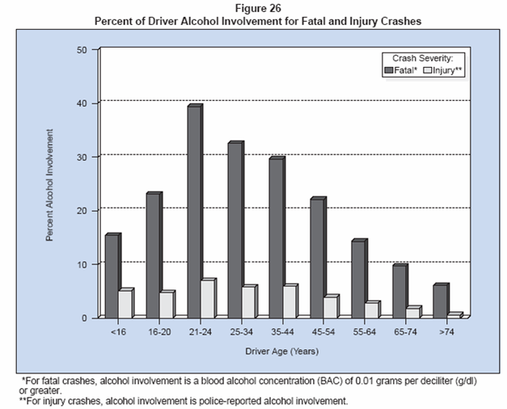

Now pay attention to the middle of the next graph, which we have outlined in red. It can be seen that the proportion of drivers in fatal crashes is less now than it was in the 1980’s. Please keep in mind that we have already discussed that the drinking age laws went into effect in 1984, and if you were to look the only age group with any type of effect from the reduction in the drinking age was the 45-54 year old group.

What none of these graphs can show is what the reason is for the decrease in fatalities. Perhaps it can be attributed to safer cars with airbags and safety equipment. Or maybe people are heeding the advice of political groups such as MADD, SADD, RADD, and the like, and not drinking as much before driving. Remember these graphs only show fatalities when the BAC was at or greater than 0.08. It is also very likely that the tougher laws and the new 0.08 BAC limit (as opposed to 0.10) have a strong effect on whether people choose to risk the drive home after drinking. Additionally, there have been stricter enforcements of seatbelt laws and helmet laws, and many areas have reduced speed limits.

Myth # 2: Cultural Perspective
The popular view is that it is popular to binge drink in the United Sates. Monday morning in class the hot topic among youth is who got drunk and how many times did they puke. By contrast, young people in other countries are introduced to drinking at home, and in moderation (at least to compared to the U.S.) This myth seems to have a little basis in fact. Drinking is seen as a ‘forbidden fruit’. You’re not supposed to have it, so you want it more. The truth about this myth is not that American youth are less responsible than their cousins over the sea, or that they can’t hold their liquor either. The truth is that because it is forbidden, no one teaches them how to drink responsibly. They don’t know how much is socially acceptable, so they tend to drink to excess. It is especially dangerous because they are can only drink in basements and hidden places, where there is no control or supervision of their activities.
Myth # 3: High School Dropouts Will Increase
From 1990 to 2000, all but 7 states had declines in high school completion. The US has slipped to 10th place in the world, and we have the highest drinking age limit.
Myth #4: Maturity Levels Too Low
You can drive at 16, operating a ton of steel and plastic all by yourself at 65 mph, You can serve in the military, on a jury, buy a shotgun or rifle, buy cigarettes (which are far more dangerous to one’s health), but you can’t have a beer or glass of wine with supper? This certainly seems like a double standard.

Myth #5: Teen Pregnancy Will Rise
Teen pregnancy rates have been steadily declining for years, but not due to less alcohol consumption. It’s been due to increased education, parental involvement, Planned Parenthood programs, and increased use of birth control.

Myth #6: Alcohol Kills Brain Cells
The moderate consumption of alcohol does not destroy brain cells – in fact, it is often associated with improved cognitive functioning. (See the IQ data in our Health Effects of Alcohol section.)

Myth #7: The Age 21 Law Has Been Successful
Some little factoids we uncovered:
- 1st use of alcohol usually begins at age 13.
- 87% of high school seniors have used alcohol.
- 2/3 of teens who drink buy own alcohol.

Recommendations/Conclusion
In conclusion, we recommend that the focus be changed from one of age to one of maturity and responsibility. We should continue to educate and teach kids about the dangers of drinking and alcoholism. They should start learning about it at home, as well as in school long before they begin drinking in public. Society can and should be able to rely on strict enforcement of laws to keep people safe. There is no actual evidence that a 19 year old is less mature than a 21 year old, and common sense tells us the opposite. Anyone mature enough to fire a gun in a war, and to be held responsible to obey all the other laws of society should also be considered mature enough to drink, and be held responsible for violations related to their drinking. Finally, the data on underage drinking is at best skewed. It is based mostly on estimates because it is an illegal activity, which makes it unlikely that most teenagers are going to come out and say exactly how much or how often they drink. By lowering the age limit, we can start getting much more accurate statistics.

Works Cited
About, INC. (2005). The Lower Drinking Age Debate Renewed. Retrieved January 31, 2005, from http://alcoholism.about.com/cs/teens/a/aa010730a.htm

Amos, Jonathon. (September 11, 2003). Call for drinking age hike (England). Retrieved March 1, 2005, from http://news.bbc.co.uk/1/hi/sci/tech/3101132.stm

Anheuser Busch Companies. (2005). Alcohol Stats- Teen Fatalities in Drunk-Driving Crashes 1982-2003. Retrieved March 2, 2005, from http://www.alcoholstats.com/1.htm

Barnes, Andrew. (1997). Lower drinking age will teach moderation, not lessons in alcoholism. Tulane University Hullabaloo Viewpoint.

BBC News. (December 6, 2000). Alcohol ‘improves IQ’. Retrieved March 2, 2005, from http://news.bbc.co.uk/1/hi/health/1058526.stm.

Beer Institute and the National Beer Wholesalers Association (March, 2000). Policy Brief: Alcohol Programs Really Are Working.

Canadian Centre for Substance Abuse. (2005). Legal Drinking Age by Province, in Canada. Retrieved February, 18, 2005 from http://www.ccsa.ca/index.asp?page=209

Center for Alcohol Marketing and Youth. (2005). Underage Drinking in the United States: A Status Report, 2004. Retrieved March 2, 2005 from http://camy.org/research/underage2004/

Center for Science in the Public Interest: Alcohol Policies Project. (February 1998). Fact Sheet: Lowering the Minimum Drinking Age Is a Bad Idea. Retrieved February 15, 2005, from http://www.cspinet.org/booze/mlpafact.htm

Hanson, David. (2004). Alcohol Advertising. Retrieved February 14, 2005, from http://www2.potsdam.edu/alcohol-info/Advertising.html

Hanson, David. (2004). Legal Drinking Age. Retrieved February 14, 2005, from http://www2.potsdam.edu/alcohol-info/LegalDrinkingAge.html

Mothers Against Drunk Driving (MADD). (2005). MADD Online. Retrieved February 18, 2005, from http://www.madd.org/home/.

Mothers Against Drunk Driving (MADD). (2005). Under 21. Retrieved February 18, 2005, from http://www.madd.org/under21/.

National Center for Statistics & Analysis (2003). State Alcohol Related Fatality Rates
2003. Washington D.C.

National Center for Statistics & Analysis (2005). Motor Vehicle Traffic Crashes as a Leading Cause of Death in the United States, 2002. Washington D.C.

National Center for Statistics & Analysis (2002). National Overview of Recent Highway Safety Data. Washington D.C.

National Commission Against Drunk Driving. (2004). Research and Resources: Traffic Safety Research Abstracts/Applications. Retrieved February 12, 2005, from http://www.ncadd.com/research_resources.cfm

NIAA Reports. (2004). APPENDIX 3
RESPONSES TO ARGUMENTS AGAINST THE MINIMUM LEGAL DRINKING AGE. Retrieved February 20, 2005, from http://www.collegedrinkingprevention.gov/Reports/Panel02/Appendix_03.aspx

National Youth Rights Association. (2005). Drinking Age. Retrieved February 15, 2005, from http://www.youthrights.org/drinkingage.shtml

National Highway Traffic Safety Administration (2002). Traffic Safety
Facts 2001. Washington D.C.

National Highway Traffic Safety Administration (2002). Traffic Safety
Facts 2001: Overview. Washington D.C.

Appendix A

Enlarged Statistical Charts

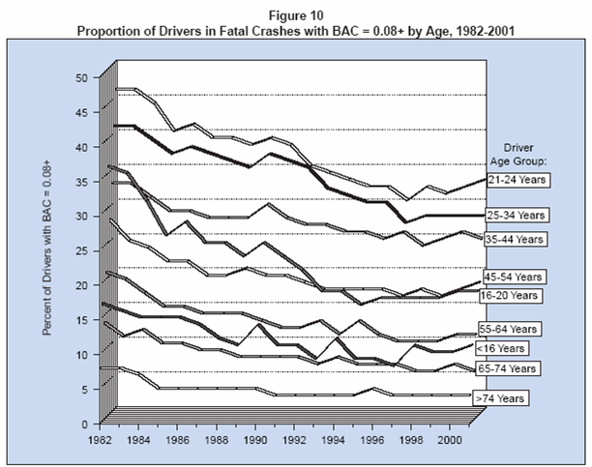

Appendix B
PowerPoint Slides (With Notes)

Slide 1 | 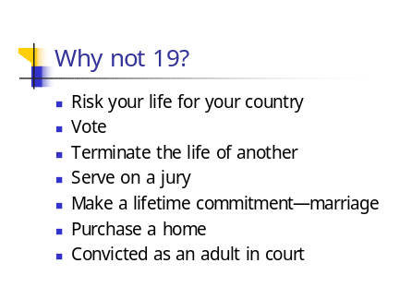 | Kati
Slide 2 | 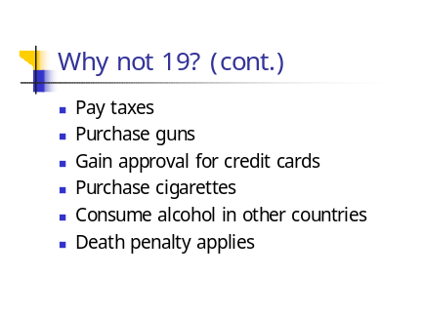 | Katie
Slide 3 | 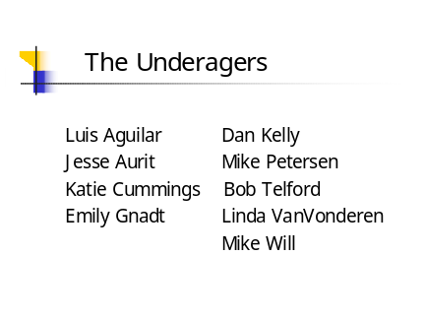 | Katie
Slide 4 | 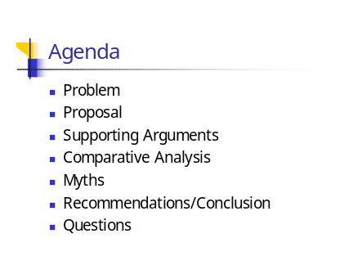 | Katie
Slide 5 | 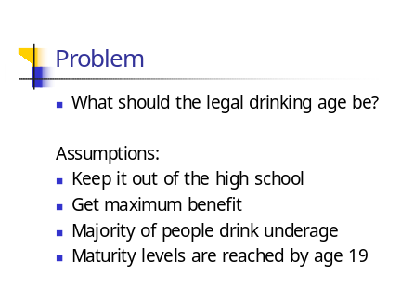 | Katie
Slide 6 | 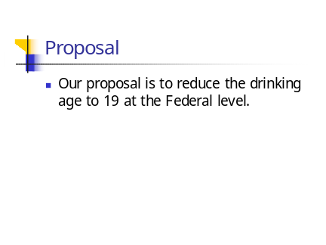 | Linda
Slide 7 | 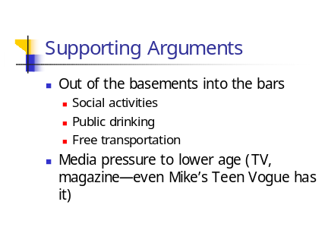 | Linda
Slide 8 | 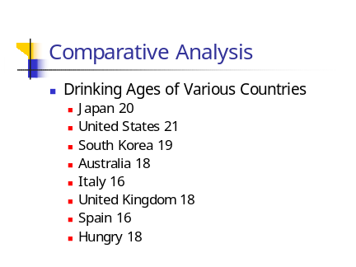 | Mike
Slide 9 | 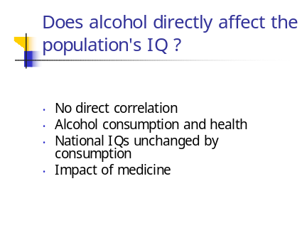 | Mike  Statistics don’t show direct proportion of alcohol consumption and a decrease of IQ levels nationally.  Studies have shown that modest alcohol consumption improves health and sharpness  Differences of nations IQs don’t include alcohol as a factor according to experts.  There are many other drugs to treat a child for some illness that can affect the brain before the age of 21.  Statistics don’t show direct proportion of alcohol consumption and a decrease of IQ levels nationally.  Studies have shown that modest alcohol consumption improves health and sharpness  Differences of nations IQs don’t include alcohol as a factor according to experts.  There are many other drugs to treat a child for some illness that can affect the brain before the age of 21.
Slide 10 | 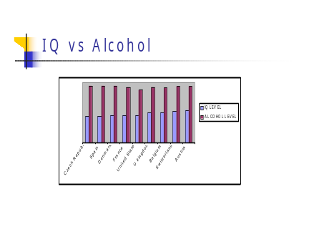 | Mike
Slide 11 |  | Mike  I would like everyone to pay attention to the middle of the graph, which I have already outline in Red. It can be seen that the proportion of drives in fatal crashes is less now than it was in the 1980’s. Please keep in mind that we have already disceuessed that the drinking age laws went into effect in 1984, and if you were to look the only age group with any type of effect from the reduction if the drinking age was the 45-54 year olds.  This may be a minor point, but if the BAC level was .10 when the data was collected, did the NhTSA assume that since the BAC was at .1, that it was at .08 for all practical purposes when designing this graph.
Slide 12 | 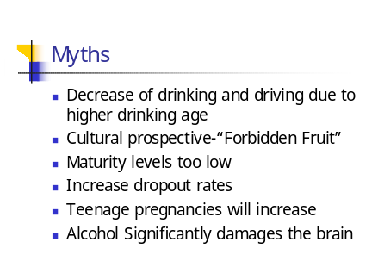 | Bob  Notes for alcohol damages the brain:  Smoking is legal at age 18 and in fact is more damaging to the body than alcohol  Study  Longitudinal Study  Current or former smokers
Slide 13 | 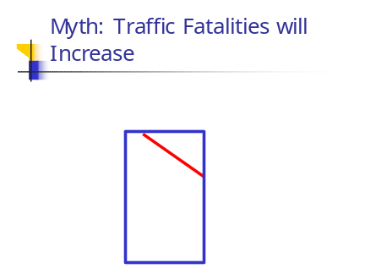 | This graph demonstrates that importance of increased restraint use and safety devices in automobile drivers. Traffic Fatalities have diminished over the past 35 years. Even when the Minimum drinking age was changed to 21, there was not a significant drop in the overall fatalities. This graph includes all motor vechicle fatilities, not just alchol.  http://www-nrd.nhtsa.dot.gov/pdf/nrd-30/NCSA/TSFAnn/TSF2001.pdf
Slide 14 | 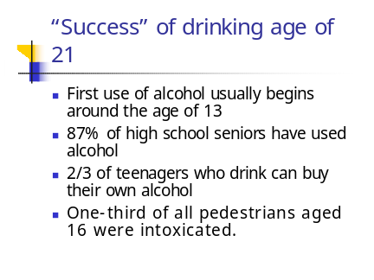 | Bob
Slide 15 | 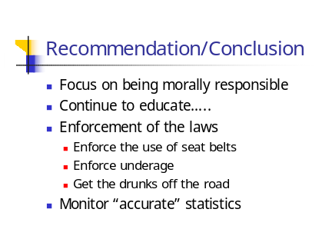 | Bob  Decrease of drinking and driving due to higher drinking age  Lower BAC levels/harsher penalties  Education concerning drunk driving  Designated driver programs  Seat belt and air bag usage  Safer automobiles  Lower speed limits  Free taxi services
Slide 16 |  | Is there any questions? ☺

Appendix C
Possible proposal to reduce irresponsible under-age drinking:

When researching the reduction of the drinking age, I came across an article in the Washington Post entitled “European Laws Place Emphasis on the Driving, Not the Drinking.” It illustrated the fact that although the legal drinking age is between 16 and 18 in most countries, the average age that they start driving is 18 or older due to higher insurance, the difficulty of passing the test, and the high use of public transportation. The argument the paper seemed to be making was that safe driving skills, and tighter control of drunk driving (sobriety checkpoints, radar units on highways, lower BAC levels etc…) were more important in the reduction of traffic deaths than whether the person was under 21 or not. The article got me thinking that there are a lot of parallels between young drivers and young drinkers in general.

- Inexperience causes dangerous mistakes.
- Illegal use of either alcohol or a motor vehicle by minors is always unsupervised.
- It is better to start slowly, and practice to improve skills.
- It is better to be educated about the rules and regulations, and expected behavior.
- Hands-On practice with supervision helps improve confidence.
- There are laws and regulations governing proper use.
- Not following the rules can result in death.
- It is a ‘right of passage’.
- It is technically a privilege, not a right.
  - (Either can be taken away by a court order.)
- Proof of identification / authorization by state is required to do either.

Before turning someone loose with a 2000 pound killing machine, we as a society try to make them, and everyone else as safe as possible. We do this by requiring that new drivers are educated, trained, and certified before we let them drive on their own. The education can either by in a formal setting such as a class, or by studying the rules and regulations in the handbook. We ensure that they understand what’s expected by requiring them to pass a written test of their knowledge to receive their learning permit. With their learning permit, they are allowed to practice driving. The practice must be in a controlled environment, either on private property (in the case of a school or class setting), or with a certified driver present if they are out in public. When they are confident enough that they can handle themselves on the road, they take a road test with a state approved official, who certifies that they can, indeed drive safely and they are issued a license. Once they get their license, they are free to drive anytime and anywhere, as long as they continue to follow the rules and regulations. If they violate them, and are caught, the license can be revoked and they will have to go through the process all over again to get it back, hopefully learning their lesson on the way.

What I propose is a similar process to promote safe drinking habits. When a person is ready to begin drinking, they should have to be educated in safe drinking either in a classroom or by studying on their own. A written test could confirm that they know everything the need to make informed and responsible decisions about when, where, and how much it is socially acceptable to drink. Once they pass the test, they would get a drinking permit. It would enable them to drink, but only a certain amount (keep the BAC about ¾ of what a fully licensed drinker can do, and only with a licensed drinker around, who will be somewhat responsible for them. The drinking ‘road-test’ would be a difficult thing to establish or control, so in lieu of that, a time-frame would suffice. For instance, a drinking permit, once issued, would be good for 6 months or a year, and if there were no violations in that time frame, it would be upgraded to a drinking license. Future problems with alcohol (public drunkenness, DUI, etc…) would be handled by the legal system, and penalties would be revocation of the drinking permit/license.

One potential drawback would be the cost of this whole new regulatory process. I think it could be handled quite easily by adding a simple checkbox to the driver’s license or state ID card. The education would take care of itself. I imagine drinking schools could be established by enterprising business people along the same lines as driving schools, and handled in the same way. The alcohol industry may even consider sponsoring or helping with startup of such places. The test would probably be an automated written test like for a driver’s license or motorcycle license. The responsibility of local taverns and shopkeepers would be the same as it always has been (check ID before purchase), they just have to look at the checkbox, instead of the birth date.

An added potential benefit would be that this license checkbox could also be used to reduce the availability of alcohol to people who are over 21, but forbidden to drink by court order because of excessive alcohol abuse (people with multiple DWI’s, or who are on a probation of some kind), which is now virtually impossible to enforce.

http://www.ama-assn.org/ama/pub/category/13246.html
? http://www.beerinsights.com/flash/alcohol/drive.htm
Source: Telegraph Herald, March 6, 2001, written by Craig Reber.
http://www.samessenger.com/20705.html
? http://www.nhtsa.com/people/Crash/crashstatistics/National%20… …Highway%20Safety%20Data%20charts.pdf
http://www-nrd.nhtsa.dot.gov/pdf/nrd-30/NCSA/TSF2001/2001overview.pdf
http://www-nrd.nhtsa.dot.gov/pdf/nrd-30/NCSA/TSFAnn/TSF2001.pdf
ets.org
Allen Guttmacher Institute. Feb 19, 2004.

